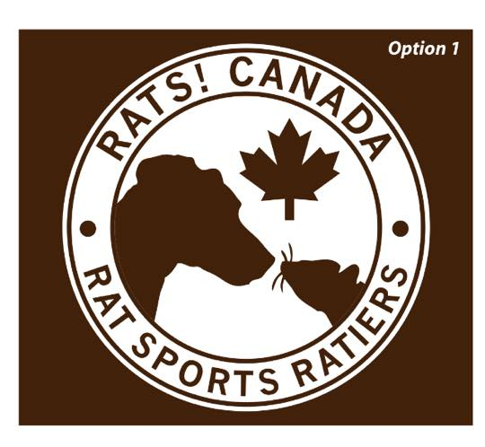
Barn Hunt Basics Workshop ~ November 28th, 2015 10 am – 2pm

Registration Form

Your Name: ____________________________________________________________
Address:________________________________________________________________
City:_________________________________ Postal Code :________________________
Phone: Home___________________ Work______________ Cell___________________
E-mail address______________________________________________ ______________
Dog(s) Name: ______________/_______________/_________________/______________
Breed or Combination of Breeds (if known):_____________________________________
We will be taking photos at our Rat Sports Events – are you okay with your photo and/or your dog’s photo being share on our website or fb page (circle) Yes / No
Payment Method - (circle) PayPal ~ E-Transfer ~ Cash
Per Team (handler & dog) __$10.00____Additional Dog(s) ____$2.00 (ea)___
Total - $_____________
Please be advised that there will be portions of the workshop where you will not be working with your dogs. A crating area will be provided.
Please bring water, snacks and food or toy reward (optional) for your dog(s).
Equipment for Dog(s): Flat collar or harness, long line or a minimum 6’ leash
NO choke chains, prong collars or head halters!
Waiver/Release Form
I realize that attendance at this Workshop is not without risk, and agree to not hold RATS! Canada, Atlantic Rat Sports (ARS), Jackie McGowan St. Croix, any/all helpers or the building/barn owners or their staff liable for any injury or damages I, my dog, or belongings may suffer during attendance of this workshop, and I assume the risk of any damage or injury done by myself and/or my dog(s) while attending these practices and/or practice sessions
Signature: _____________________________________________

