A Competition Obedience Seminar with

Janice Gunn
The Kennebecasis Obedience Club is pleased to present
September 15th & 16th, 2018
Bill McGuire Memorial Centre, Rothesay, New Brunswick
Working Spots $250 (early bird) (Limit of 20) - $300 after July 15th, 2018
$125 for Auditors (Unlimited) - $150 after July 15th. 2018

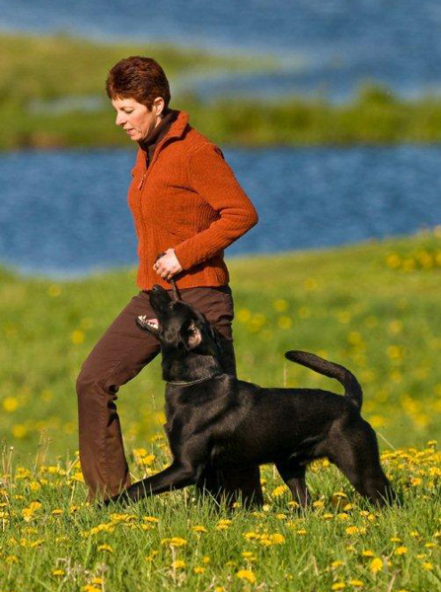

Join us for new training ideas, building a relationship with your dog, how to make training a “game”, training using positive methods, how to keep your dog engaged, fun proofing exercises and much, much more! Each day will include new training ideas, group work.
About Janice
Janice has been involved with training dogs for the past 40 years. She has presented numerous workshops and has produced 5 successful DVD’s on obedience training. She has earned 7 OTCH titles and multiple 200 scores with five different dogs. Her own dogs multi task in retriever field trials and have earned OTCH, MH and FC/AFC titles. These are the highest obtainable levels in both obedience and field.

Seminar Details
- Limited to 20 working spots.
- Early bird registration fee is $250 for a working spot - $300 after July 15^{th.}
- Early bird registration fee is $125 for an audit spot - $150 after July 15th.
- A $25 cancellation fee will be charged for cancellations prior to July 15th, 2018. There will be no refunds issued for cancellations after July 15th, 2018.
- Payments must be received with registrations by cheque or money order. Please make cheques payable to Kennebecasis Obedience Club. No post-dated cheques please.
- You will be notified by email when your registration form and payment have been received. Further details will be emailed to entrants before the seminar.

Contact Phyllis McCullum at starwoodaussies@gmail.com for more information.

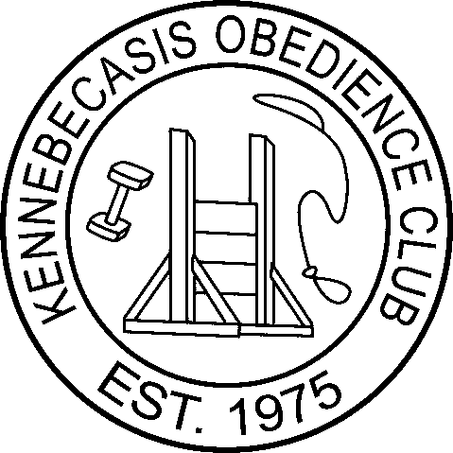
www.whatagooddog.ca

Janice Gunn Competition Obedience Seminar
Registration Form
Please mail registration form and payment to Phyllis McCullum
107 Roachville Rd., Roachville, NB, E4G 2J2

 |  | Working Audit
Name:
Address:
City, Province:
Postal Code:
Phone Number: |  | Home: Work: Cell:
Email Address:
Working Teams Only
Dog’s Name: |  |  |  | Age:
Sex: | Male Female |  | Spayed/Neutered? |  | Yes No

Release
I, __________________________________________, will not hold Phyllis McCullum, The Kennebecasis Obedience Club, its officers and directors, Janice Gunn, or the Town of Rothesay liable for any injuries or damages sustained by myself or my dog(s). Signature_______________________________________
Date __________________________________________

